22-23 Gateway STEM
Uniform Schedule
Monday  Tuesday  Wednesday  Thursday | Black/Grey Gateway embroidered polo, long -sleeved, sweatshirt or Gateway T-shirt and appropriate bottoms  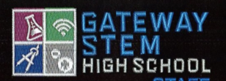
Friday | $1 Dress Down Day to support Gateway Clubs and Teams  If you choose not to bring a $1, that’s o.k., but you must be in  Black/Grey Gateway embroidered polo, long -sleeved, sweatshirt or Gateway T-shirt and appropriate bottoms  

*Shirts can be purchased in the Jag Town Store during lunch periods.

